NFL Combine Data Analysis

Introduction
NFL Draft Day. Perhaps the most-watched spectacle in the world which determines which young men will become millionaires, and which will have to search for careers outside the game they love. This event takes place every year and doesn’t just involve those fresh out of college. In fact, it is very common for players to forego finishing their college degrees in order to declare for the draft. However, this is a risky proposition due to the uncertainty surrounding whether or not the player will actually get drafted. All too often, players will declare for the draft early, but then they just don’t get drafted. This leaves them in a tough position to figure out how to move forward. Before each draft there is an NFL combine, which allows players declaring for the draft to show off their athletic abilities. While game film is an important part of the draft and scouting process, the Combine is believed to play an important role as well. Utilizing data from previous NFL Combines, key insights can be gained as to what the important factors of a player getting drafted are and can potentially help determine whether or not any particular player is expected to be selected in the NFL Draft.

Analysis and Models

About the Data
The data which we are analyzing contains records for players participating in the NFL Combine from 2000 – 2018. Each record represents one individual player along with their Combine results, and their draft position. It is important to note that players which participated in a Combine, but did not get drafted, are also included in this data set. A quick look at the first 5 rows of the data set can be seen below:

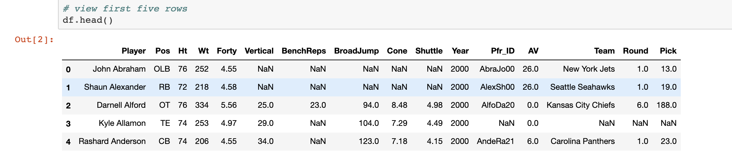

Overall, the variables provided are straightforward. With a nice mix of categorical and continuous data, this data set should be able to provide a holistic look at the relationship between Combine results and the chances of being drafted.

Data Preparation
A number of basic pre-processing steps were undertaken in order to prepare our data for analysis. The first step was to examine how complete the original data set was by counting the number of null values in each column:
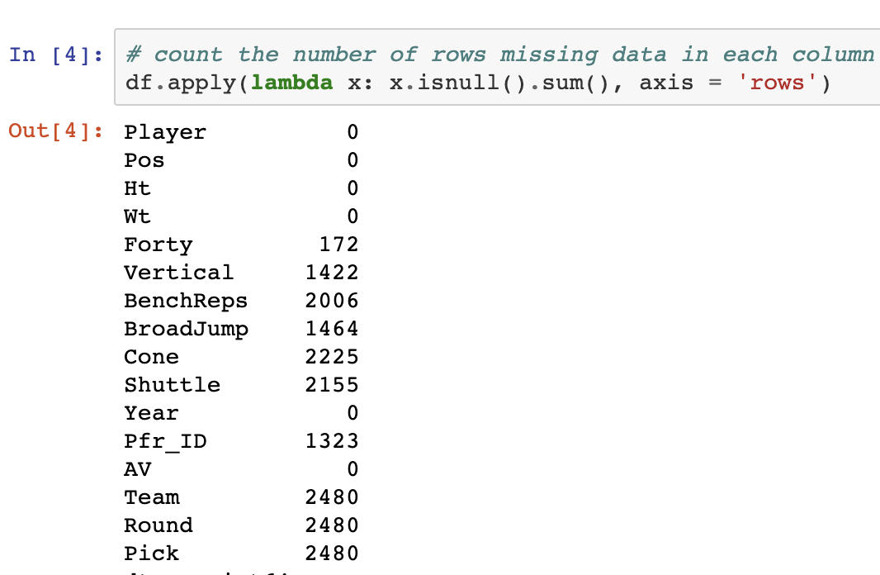

As shown above, there is quite a bit of missing data across some of our columns. However, at a closer look, this makes sense. For “Team”, “Round”, and “Pick”, the missing data represents players not being selected in the Draft. For the Combine values, it makes sense that not every player completes every drill, especially for certain positions such as Quarterback or Kicker. With this understanding of the data, the following approaches were used to handle these null values:

- The null values for “Team”, “Round”, and “Pick” were replaced with the value “Undrafted”
- The null values for the Combine results were replaced by the Median value for that player’s position

Additionally, a custom column was added to designate whether or not each player was drafted:

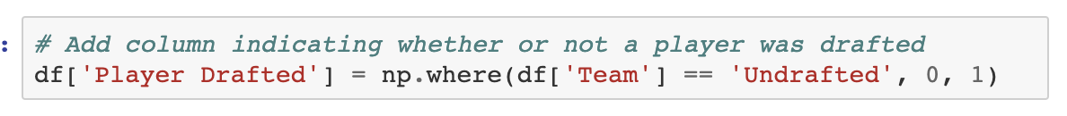

Exploratory Data Analysis
With the data in a suitable form for exploration, exploratory data analysis was able to commence. First, a look was taken at the count of drafted players vs undrafted players. A 1 indicates a player was drafted, and a 0 indicates a player was not:

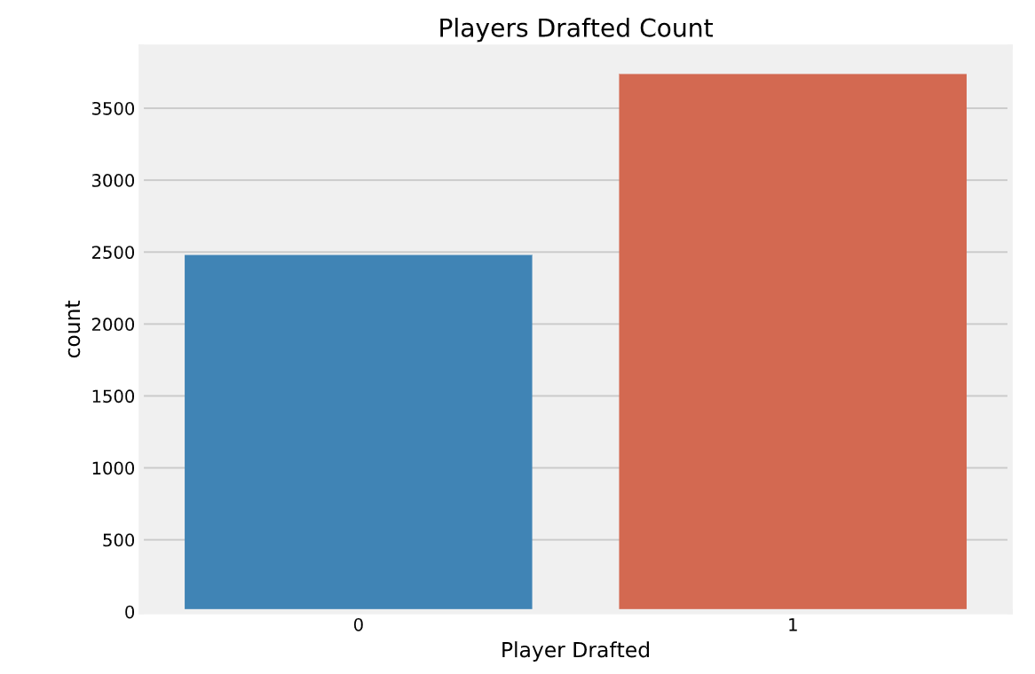

Next, it was important to see the number players drafted in each round:

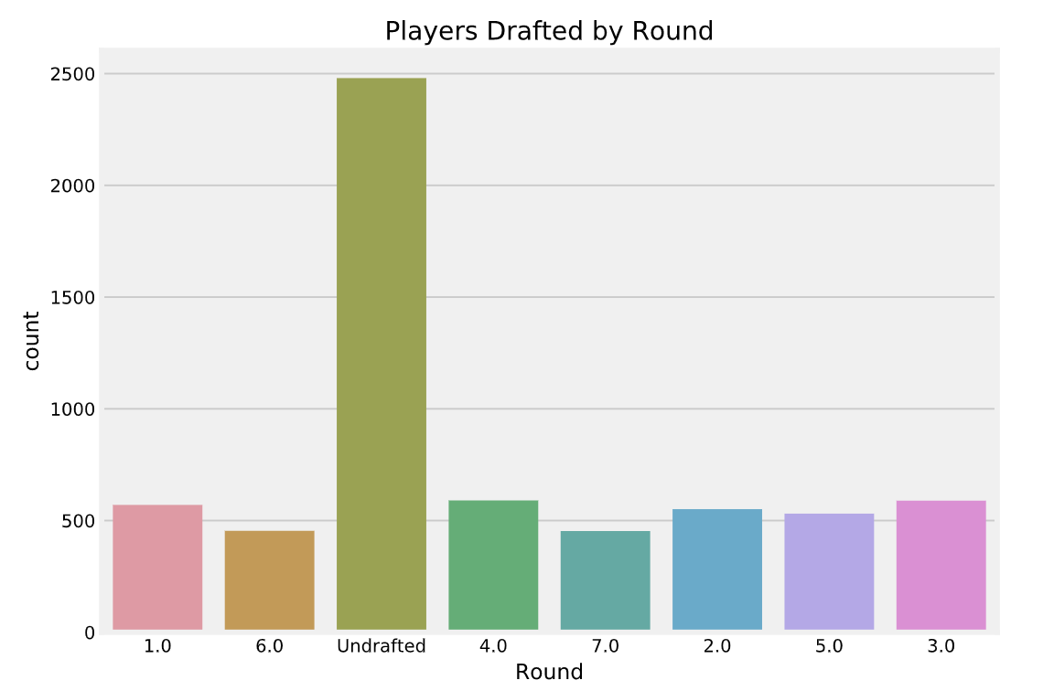

The number of Undrafted players is the leader, which makes sense. Everything else is about even as expected, with rounds 3 and 4 being the most common for players who participated in the Combine and got drafted.

Next, the count of each Position in the data set was examined:

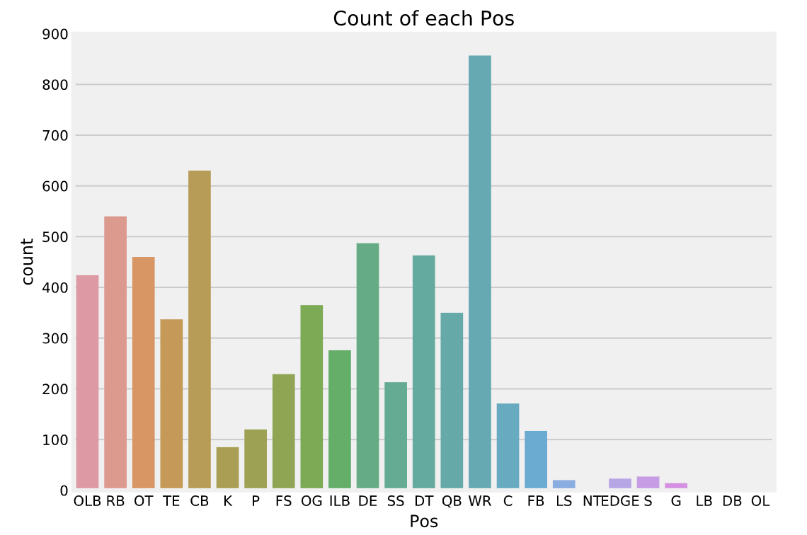
An argument could be made that some of the positions should be consolidated. For example, SS and FS are both Safeties, while DB could be a catch-all for Safeties and CBs. For the purposes of this analysis, no changes were made to any of the positions. It is possible a more “general” position impacts draft grade as opposed to a more “specific” position, the decision was made to see how things play out with the original data. For the final piece of exploration, the draft % by Position was calculated:

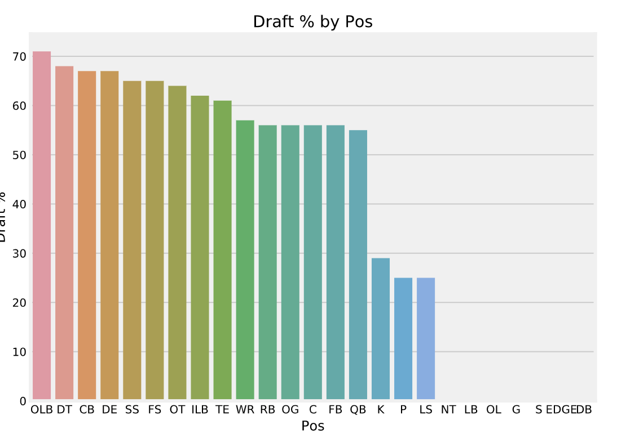
It looks like OLB had the highest draft %, with a few positions having no players drafted at all.

Models
After exploring the data, the decision was made to set “Player Drafted” as the target variable, so that models can be constructed to help predict whether or not a given player will be selected in the NFL Draft. In order to prep the data for final model building, the following pre-processing steps were undertaken:

- Removed the following columns:
  - Pick
  - Round
  - AV
  - Team
  - Index
  - Year
  - Player
- Split the features and labels
- One-hot encoded the categorical variables
- Split the data into a “Training set” and a “Test set”
  - 75% was allocated to training, while 25% was allocated to testing

The columns which were removed were removed to ensure no noise was added to the data. Additionally, the goal was to really focus on variables which could be dependent on a player’s performance. The following features were used in the models:

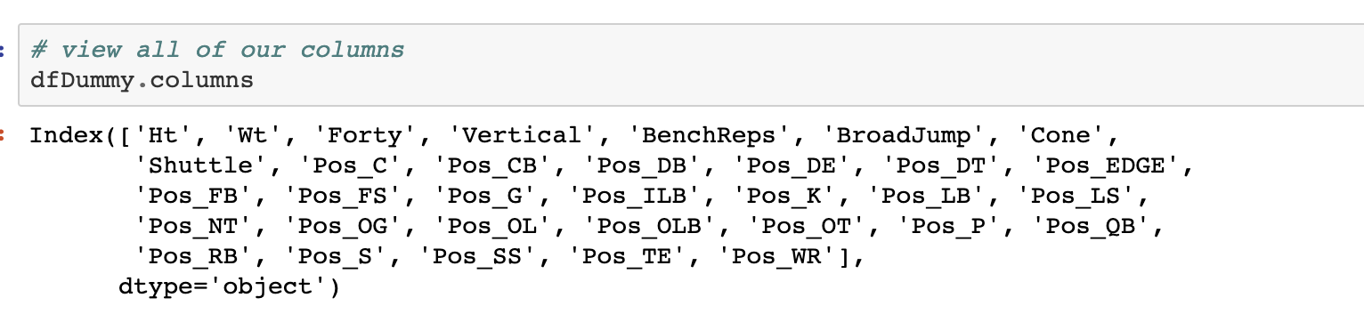

It is important to note the positional values will be represented as 1s and 0s due to the one-hot encoding. The following models were created to assist in the prediction of whether or not a player will be drafted: A random forest model, and a logistic regression model. The performance of each model is as follows:

Random Forest
- 69.5% Precision
- Did a decent job at predicting drafted players, but did not perform as well for undrafted players.

Logistic Regression
- 83.9% Accuracy
- 68.8% Precision
- Similar to the random forest model, predicting drafted players was easier for this model.

While the overall performance of the 2 models was okay, but not great, some great insights were gained by analyzing feature importances from each model. In fact, there was a bit of difference between the tow. For the random forest model, results from the Combine seemed to be the dominating factor in whether or not a player was drafted. However, this wasn’t necessarily the case for the logistic regression model. One of the key reasons the logistic regression model was used, is because it enables the ability to not only see the impact of each feature, but the direction as well. A closer look at the coefficients for the logistic regression is below:

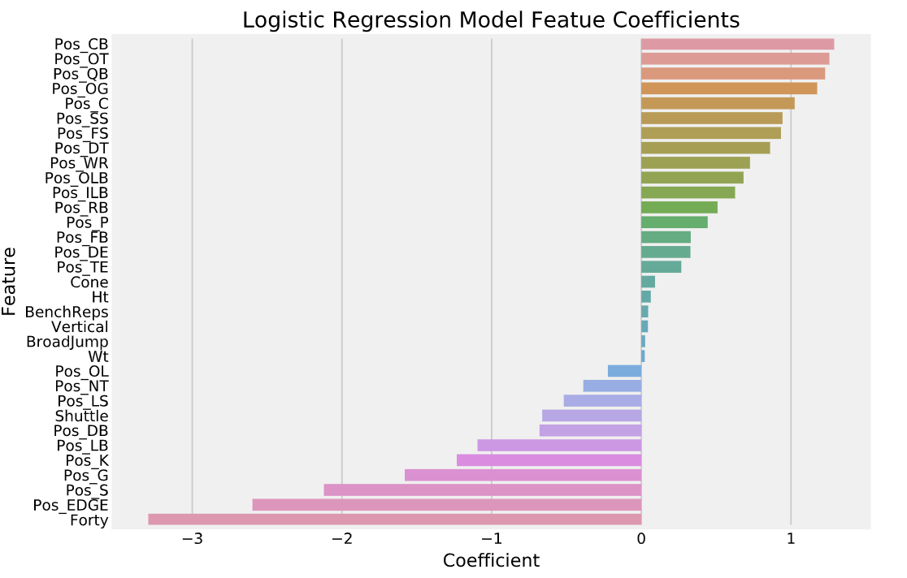

As can be seen above, it looks like being an offensive lineman, CB, or QB has a strong impact on getting drafted. Additionally, a low Forty time can drastically boost your odds of being drafted.

Conclusion
As it turns out, brief analysis of NFL Combine data can provide some great insights into what it takes to get drafted in the NFL. Based on the models we created, it appears a player’s position plays a strong role in whether or not they get drafted. Additionally, a low Forty time can drastically improve a player’s chances of getting drafted. However, according to the logistic regression model, the other drills at the Combine don’t appear to have that much of an impact. It is important to note that a lot more could have been done with this data set given more time. For example, further analysis into predicting a player’s round or team could also be performed given more time and research.

